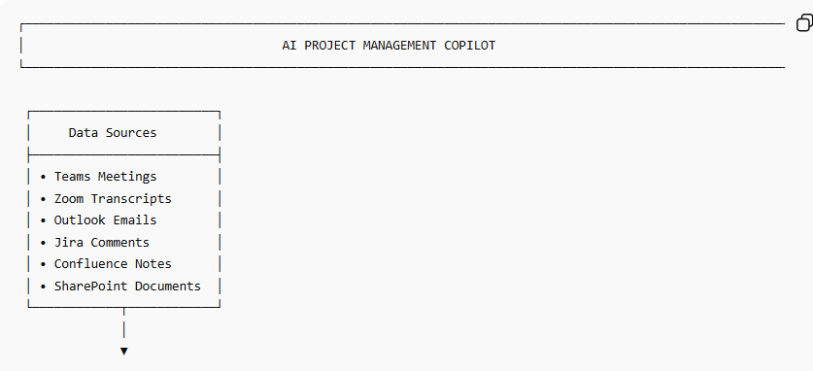
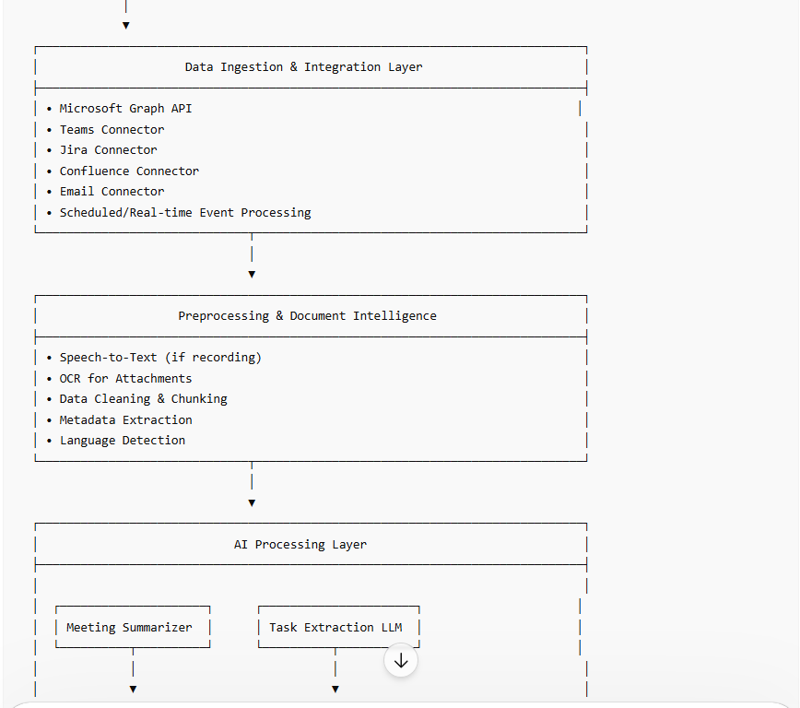
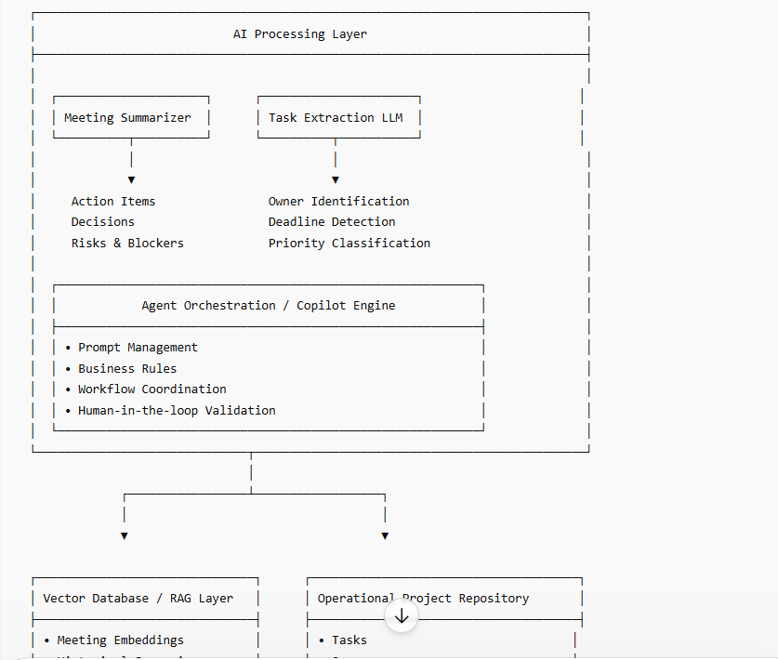
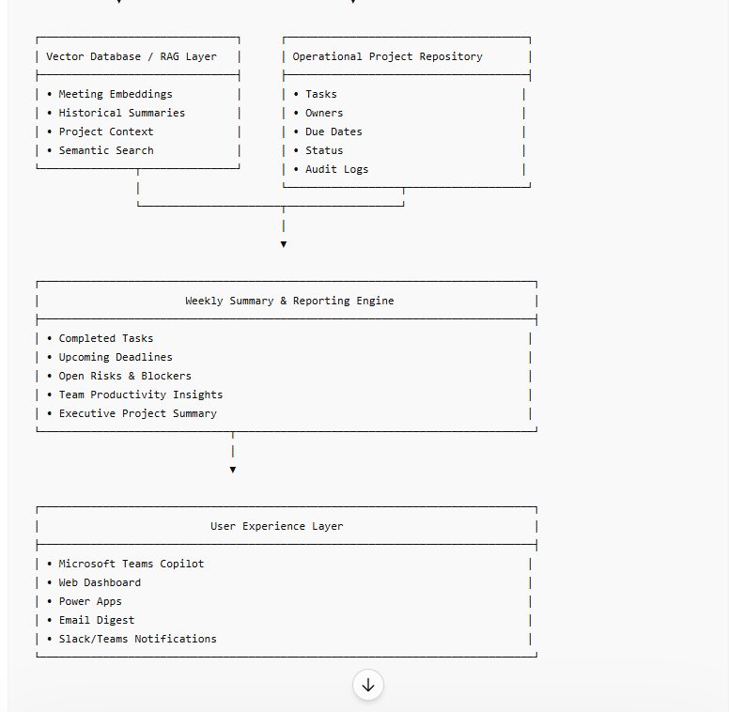
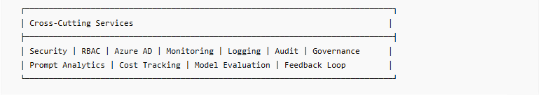
Technology Mapping (Microsoft-Centric)
Layer | Recommended Services
Ingestion | Microsoft Graph API, Power Automate
Storage | Azure SQL, SharePoint, Dataverse
AI Models | Azure OpenAI Service
RAG | Azure AI Search
Orchestration | Microsoft Copilot Studio, LangGraph
Dashboard | Power BI
Notifications | Teams, Outlook
Identity | Microsoft Entra ID
Key AI Outputs
- Extract action items from meeting notes.
- Identify task owner.
- Detect deadlines and milestones.
- Highlight risks/blockers.
- Create project status updates.
- Generate executive weekly summaries.
- Push tasks automatically to Jira/Azure DevOps.
- Answer project-related questions through a Copilot chat interface.
This architecture is suitable for an Enterprise Architect / Solution Architect interview and can be implemented using Copilot Studio + Azure OpenAI + Microsoft Graph + Power Platform.

